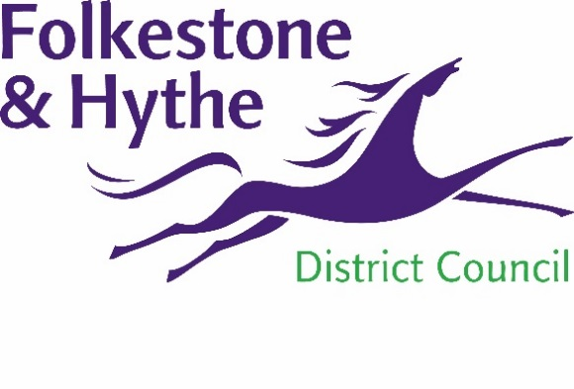
NEWS RELEASE

1 November 2019

HIGH COURT UPHOLDS COUNCIL PLANNING DECISION

Permission to apply for judicial review on the planning permission for the Princes Parade development has been refused.
Folkestone & Hythe District Council’s (F&HDC) planning decision has been upheld by the High Court with the judge – Mr. Justice Lieven – rebutting the arguments for judicial review in turn. He has awarded up to £5,000 to the council in costs.
Cllr David Monk, F&HDC Leader, said: “Planning decisions are always considered with the appropriate due diligence. We ensure the correct procedure is followed and respected.
“I am delighted our planning decision has been upheld and we can now get on with continuing to provide services for our residents and build a district that we can all be proud of.”
The applicant has seven days in which to ask for the decision to be reconsidered.

ENDS
Notes to Editors
For more information, please email communications@folkestone-hythe.gov.uk

Follow us on Facebook: @FolkestoneandHytheDC
Follow us on Twitter: @fstonehythedc
Follow us on Instagram: @folkestonehythedc
Follow us on LinkedIn: Folkestone & Hythe District Council

